SIMATS ENGINEERING ASSESSMENT TOOL 1

COURSE CODE: CSA0713
COURSE NAME: COMPUTER NETWORKS

COURSE OUTCOME COVERED
CO2: Configure IP addressing schemes, subnetting, and basic routing techniques
using simulation tool, for efficient network design and topology. (BL3)
Assessment Tool Weightage: 40%

Annexure A ANALYTICAL PROBLEM SOLVING
Code of Conduct:
I A sreenath(192525119 (Name / Reg No) certify that this submission is my original work
and that I have adhered to the guidelines specified for this assessment.
I understand that any violation of academic integrity rules will result in disciplinary action.

Signature of the student: A sreenath
- Suppose we want to transmit the message 11100011 and protect it from errors using the
CRC polynomial X3+1.
i.) Use polynomial long division to determine the message that should be transmitted.
ii) Suppose the leftmost bit of the message is inverted due to noise on the transmission
link. What is the result of the receiver&#39;s CRC calculation? How does the receiver know that
an error has occurred? Sol..

- Polynomial Long Division to Determine Transmitted Message
  - Message bits:
  - Generator polynomial: , which corresponds to binary
Step 1: Append zeros Since the generator polynomial has degree 3, append 3 zeros to the message:
Step 2: Divide by generator polynomial Perform binary (mod 2) polynomial long division:
  - Dividend:
  - Divisor:
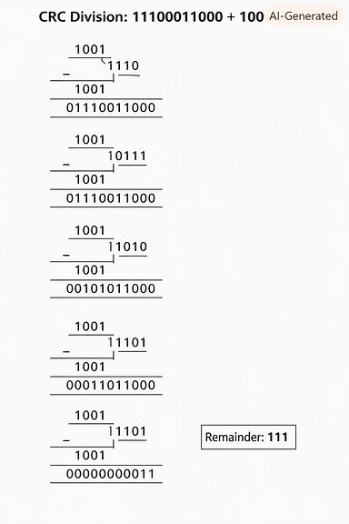

Carry out XOR division:

- Divide first 4 bits by → remainder .
- Continue sliding through the dividend, performing XOR whenever the leftmost bit is 1.
- At the end, the remainder is 111.
Step 3: Form transmitted codeword The transmitted message is the original message plus the remainder:
So the transmitted codeword is: 11100011111

- Error Detection at Receiver
  - Suppose the leftmost bit is inverted during transmission. Transmitted: Received:
Step 1: Receiver divides received message by generator polynomial Perform CRC check:
divide by .
Step 2: Result of division The remainder will not be zero (since the error changed the polynomial structure).
Step 3: Error detection CRC works because any nonzero remainder indicates corruption. Thus, the receiver knows an error occurred because the remainder ≠ 0.

- a) A network with bandwidth of 10 Mbps can pass only an average of 12,000 frames per
minute with each frame carrying an average of 10,000 bits. What is the throughput of this
network?
b) A network has a bandwidth of 3000 Hz (300 to 3300 Hz) assigned for data
communications. The signal- to-noise ratio is 3162. Find the channel capacity

Sol..

- Throughput of the Network

  - Bandwidth available:
  - Frames per minute:
  - Bits per frame:
Step 1: Calculate bits transmitted per minute Step 2: Convert to bits per second

Answer:
The throughput of the network is 2 Mbps.
This is much lower than the available bandwidth (10 Mbps), showing inefficiency due to overheads, delays, or errors.
- Channel Capacity (Shannon’s Theorem)
  - Bandwidth (B):
  - Signal-to-noise ratio (SNR): Step 1: Use Shannon’s formula Step 2: Substitute values
Step 3: Approximate logarithm

Step 4: Final capacity Answer:
The channel capacity is about 34.9 kbps.

- A multispecialty hospital uses wireless patient-monitoring devices to continuously transmit
patients&#39; heart rate and blood pressure readings to a central monitoring station. Since the data
is transmitted over a wireless channel, electromagnetic interference occasionally changes one
bit during transmission. To ensure that doctors receive accurate patient information without
waiting for retransmission, the hospital implements the Hamming (12,8) error-correcting
code. Sol..

Step 1: What is Hamming (12,8)?
- It takes 8 data bits (the patient’s heart rate and blood pressure readings in binary form).
- It adds 4 parity bits, making a 12-bit codeword.
- These parity bits are placed at positions that are powers of 2 (1, 2, 4, 8).
- The parity bits are computed so that each covers a unique combination of data bits, enabling single-bit error correction.
 Step 2: Transmission Process
- The patient’s reading (say, 8-bit binary data) is encoded into a 12-bit Hamming codeword.
- This codeword is transmitted wirelessly.
- If electromagnetic interference flips one bit, the receiver can detect and correct it immediately.
 Step 3: Error Detection and Correction
  - At the receiver, the 12-bit codeword is checked using the parity-check matrix.
  - If no error, the syndrome = 0.
  - If one bit error, the syndrome points to the exact bit position that is wrong.
  - The receiver flips that bit back, restoring the original 8-bit patient data.
  - If two bits are corrupted, Hamming (12,8) can detect but not correct — the system would then flag an error.
 Step 4: Why This Matters for the Hospital
  - Doctors receive accurate patient data in real-time without waiting for retransmission.
  - Single-bit errors (most common in wireless interference) are corrected instantly.
  - This ensures continuous monitoring of critical vitals like heart rate and blood pressure.
  - Reliability is crucial — a missed or delayed reading could affect patient safety.

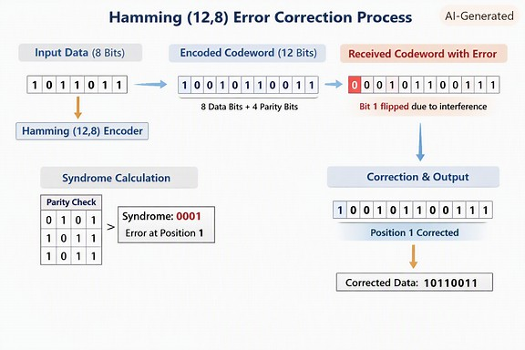

- a) A company uses the IP address 172.16.10.0/24 and has implemented subnetting using a
/27 subnet mask for its internal departments. Using the given subnet mask, apply subnetting
techniques to calculate the total number of subnets created and the number of usable hosts per
subnet. Determine the subnet to which the IP address 172.16.10.78 belongs. Identify the
network address and broadcast address for that subnet. Also, determine whether the IP address
172.16.10.95 falls within the same subnet range based on the given configuration.

b) A network uses the Internet Protocol version 6 address

2001:0db8:0000:0000:0000:ff00:0042:8329. Apply IPv6
addressing rules to compress the
given address into its shortest form and then expand the compressed address back to its full

notation. Using a prefix length of /64, determine the network prefix of the given address.
Also, calculate the total number of possible host addresses available within this network based
on the given prefix length.

Sol…

- IPv4 Subnetting Analysis
  - Given network: 172.16.10.0/24
  - New subnet mask: /27 → 255.255.255.224
  - Subnet bits borrowed:
  - Total subnets:
  - Hosts per subnet: usable hosts

Subnet ranges:
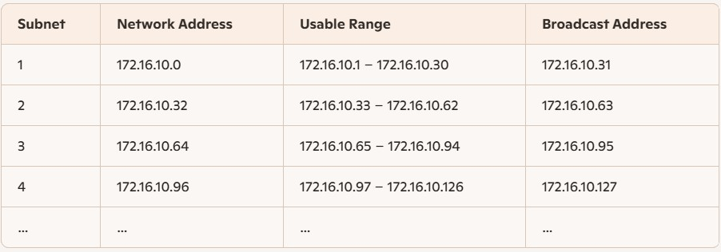

IP address 172.16.10.78
→ Falls within Subnet 3 (172.16.10.64/27)
  - Network address: 172.16.10.64
  - Broadcast address: 172.16.10.95
  - Usable range: 172.16.10.65 – 172.16.10.94

Check IP 172.16.10.95: → It’s the broadcast address of that subnet, not a usable host. Hence, it does not fall within the usable range.

- IPv6 Address Analysis
Given address: 2001:0db8:0000:0000:0000:ff00:0042:8329
Compressed form: 2001:db8::ff00:42:8329
Expanded form: 2001:0db8:0000:0000:0000:ff00:0042:8329
Prefix length: /64
→ Network prefix: 2001:db8:0:0::/64 Host bits:
→ Total possible host addresses:
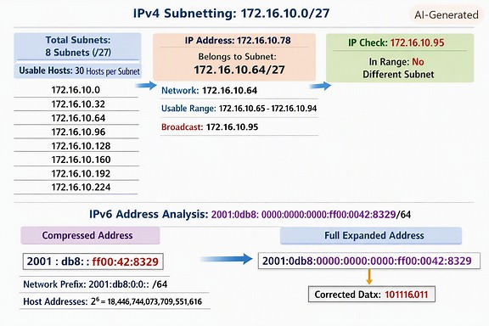

- A university is conducting an online semester examination for 8,000 students
simultaneously. At exactly 10:00 AM, the examination server begins transmitting encrypted
question papers to all students. The university server is connected through a 10 Gbps high-
speed network, while students access the examination portal using different internet
connections such as fiber broadband (100 Mbps), home Wi-Fi (20 Mbps), and mobile
networks (5–10 Mbps). During the first few minutes of the

examination, many students with
slower internet connections report incomplete downloads, repeated retransmissions, delayed
acknowledgments, and temporary freezing of the examination portal. Network administrators
observe that the server continues transmitting data at a high rate even though several student
devices are unable to receive and process packets at the same speed. This results in receiver
buffer overflow, unnecessary retransmissions, increased network traffic, and delays in
delivering the question papers. Analyze the above scenario and identify the primary
networking problem. Explain how the mismatch between the sender&#39;s transmission speed and
the receiver&#39;s processing capability affects communication.
Sol..

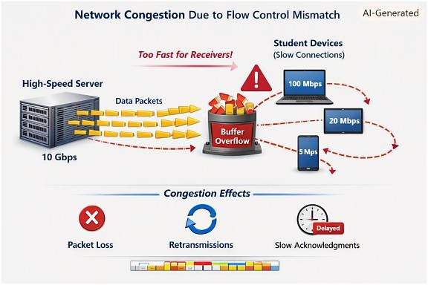

At 10:00 AM, the university server transmits encrypted question papers to 8,000 students simultaneously. The server operates at 10 Gbps, while students have varying connection speeds — 100 Mbps, 20 Mbps, and 5–10 Mbps.
Observed Problems:
- Incomplete downloads
- Repeated retransmissions
- Delayed acknowledgments

- Freezing of the examination portal
- Receiver buffer overflow

Primary Networking Problem:
The issue is “Flow Control and Congestion Control Mismatch.”
- The sender (server) transmits data at a rate far higher than what many receivers (students) can handle.
- This mismatch causes receiver buffer overflow, leading to packet loss and retransmissions.
- The network becomes congested, increasing latency and reducing throughput.

